# Data Types

## Variables and Constants

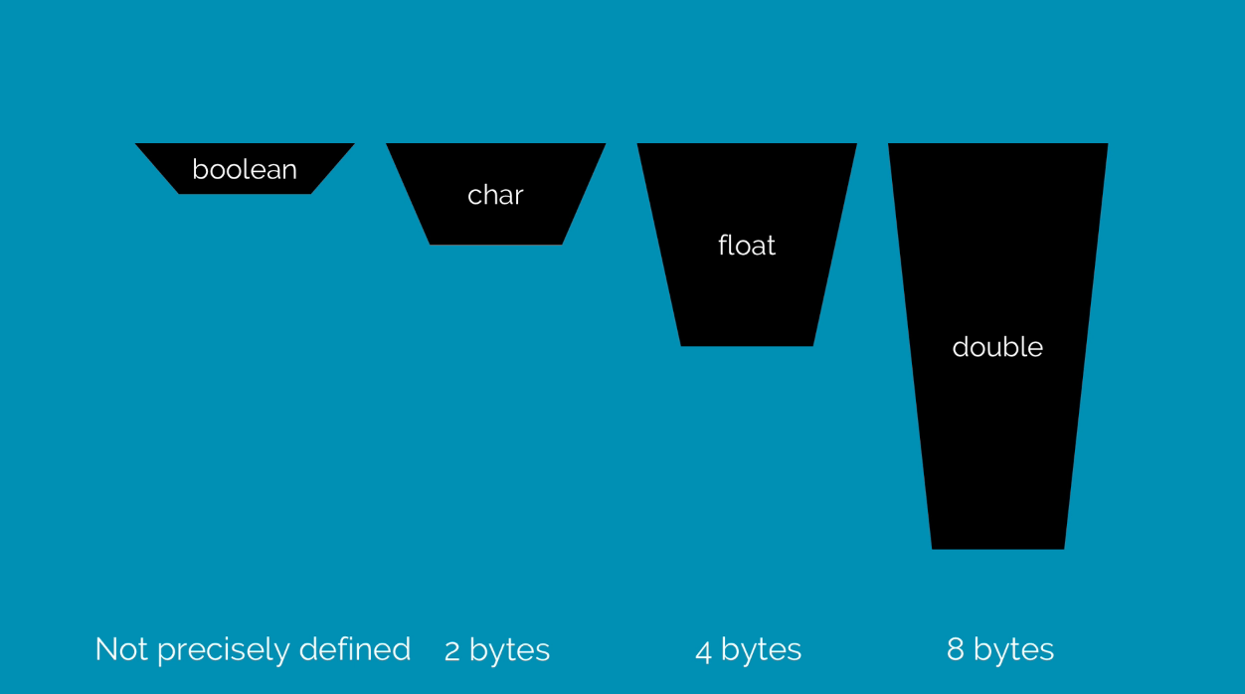

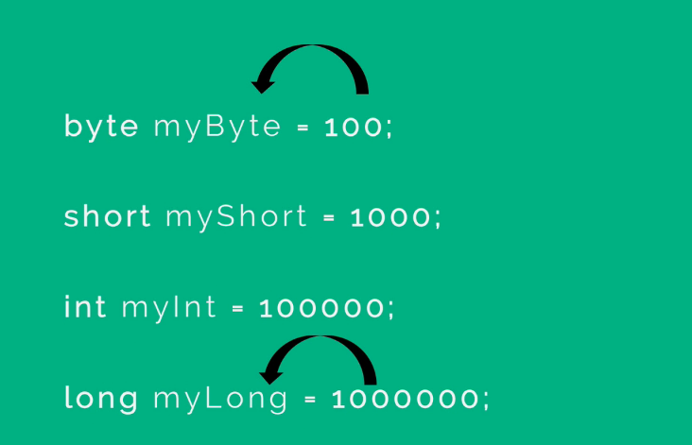

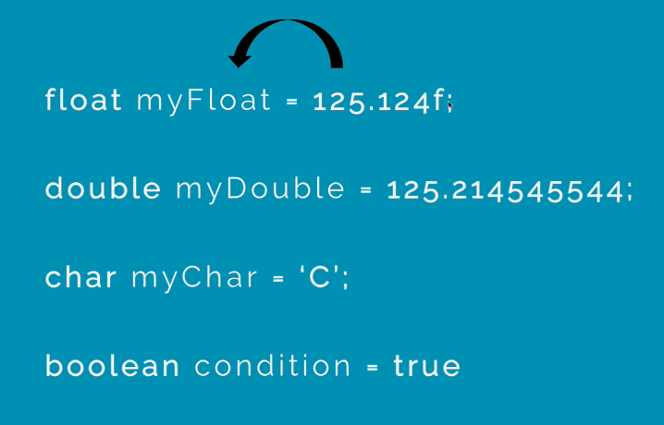

Constants in Java.



## Variables and Constants Example

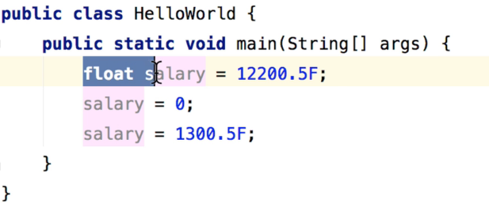

## Typecasting in Java

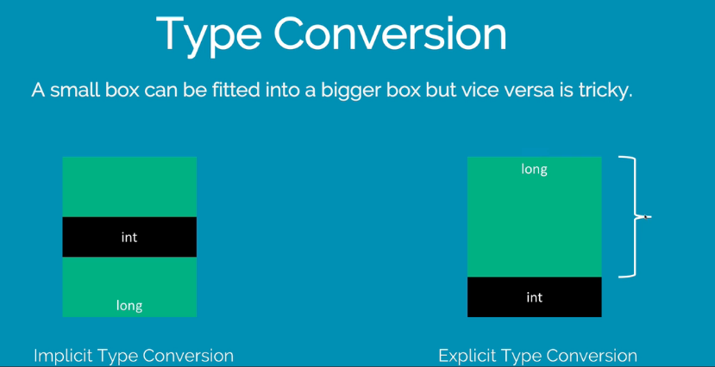

## Typecasting in Java Examples

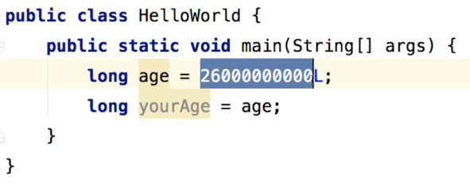

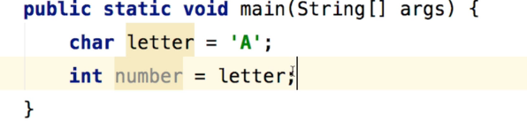

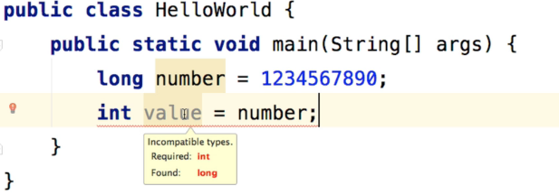

# Operators

## Arithmetic Operators

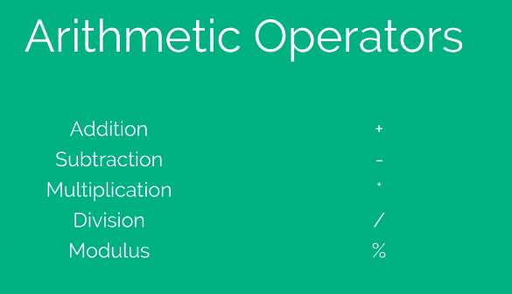

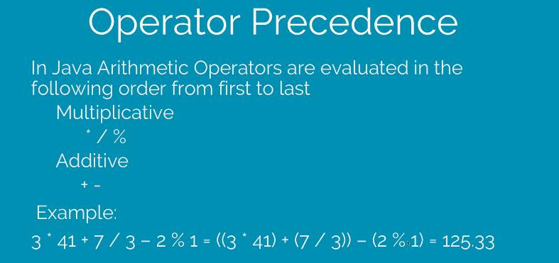

## Relational Operators in Java

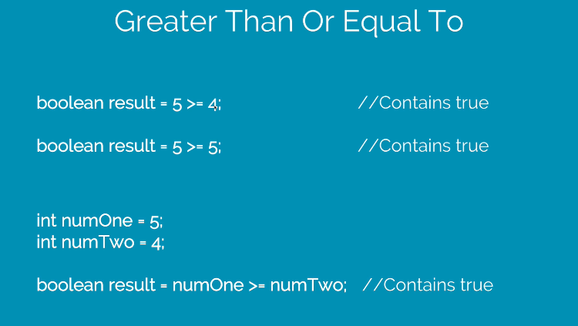

## Assignment Operators in Java

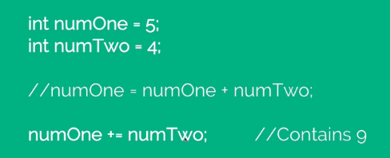

## Increment and Decrement and Logical Operators

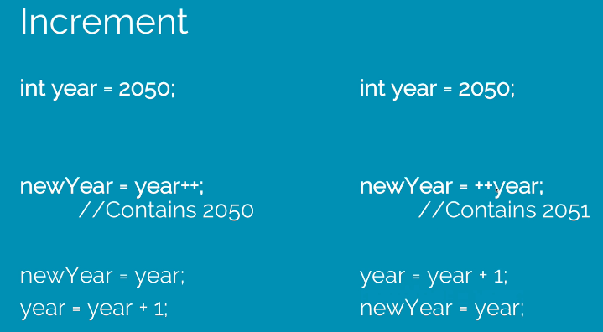

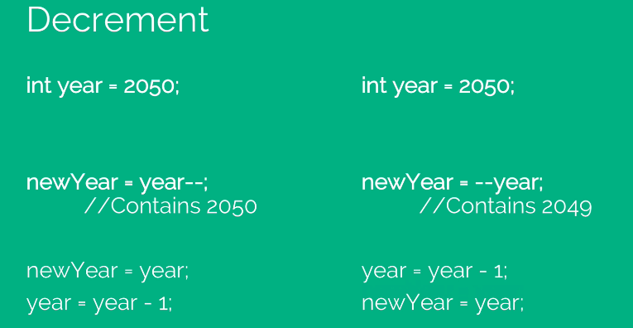

Logical Operators

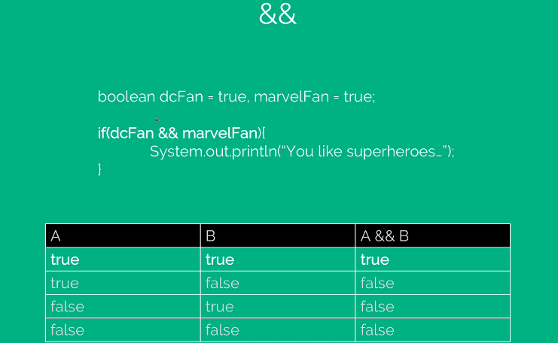

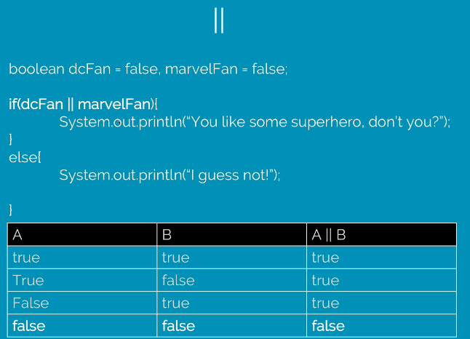

# Conditional Statements

## If else

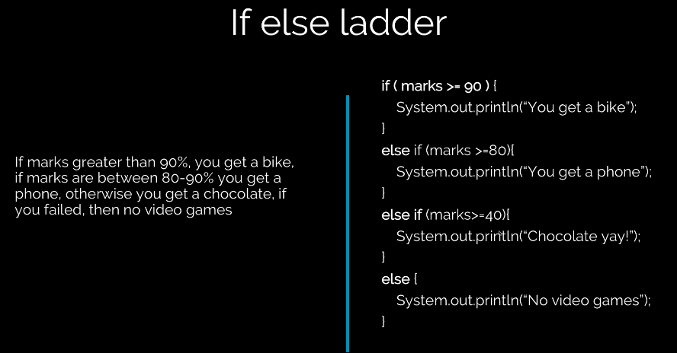

## Ternary Operator

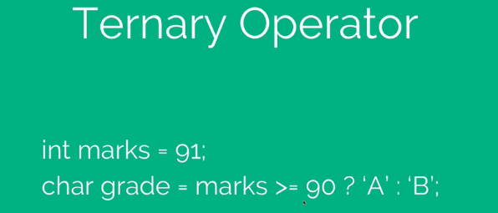

## Switch Statement

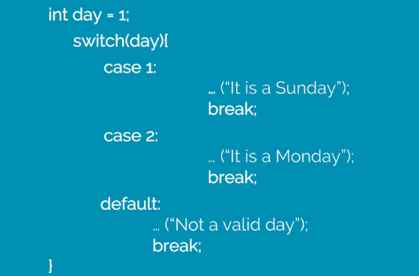

# Loops

## For Loop

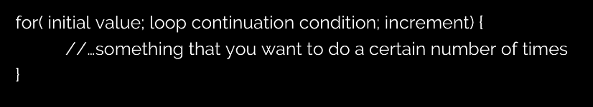

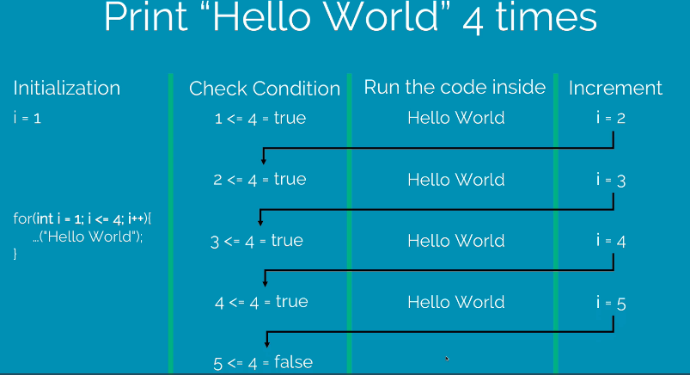

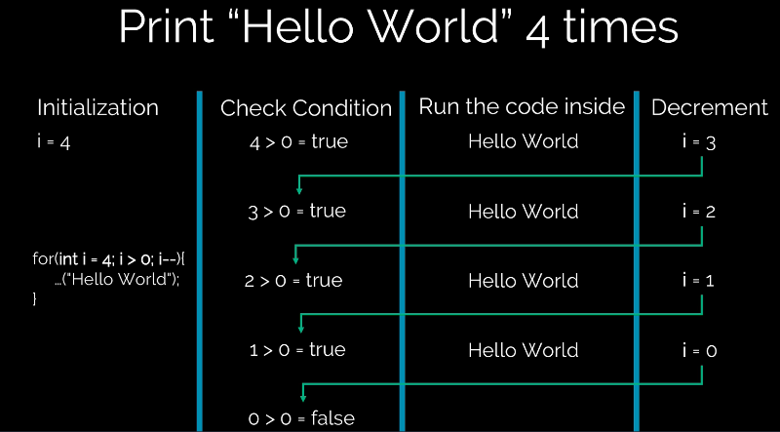

## While Loop

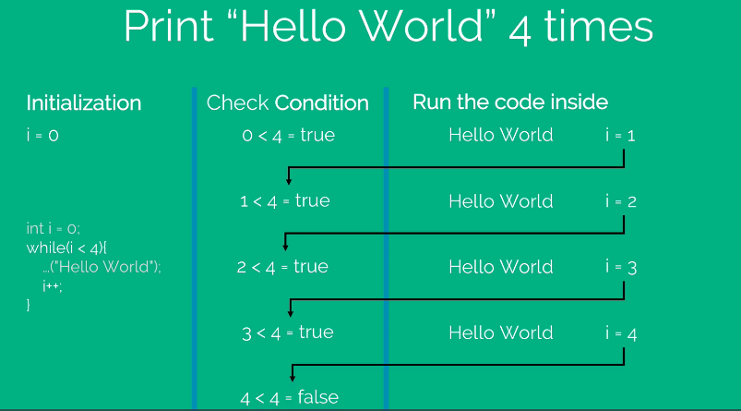

## Break Statement

## Continue Statement

# Strings

## String

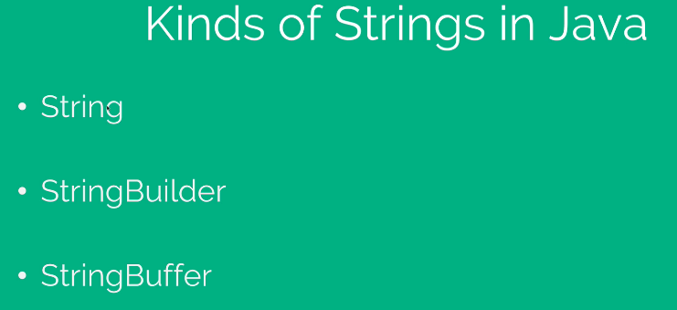

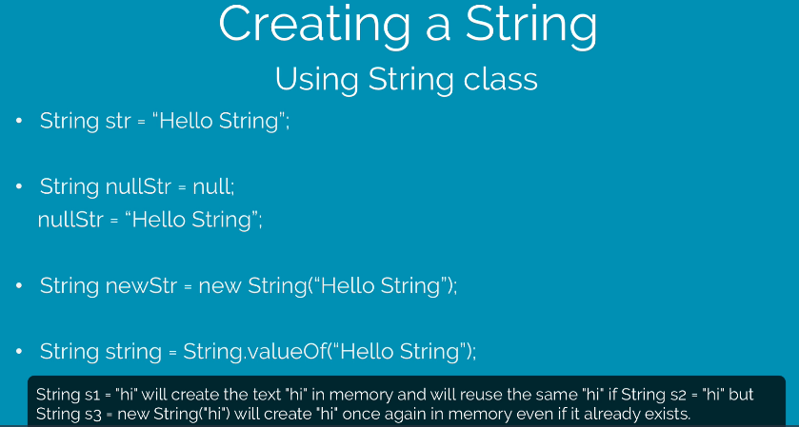

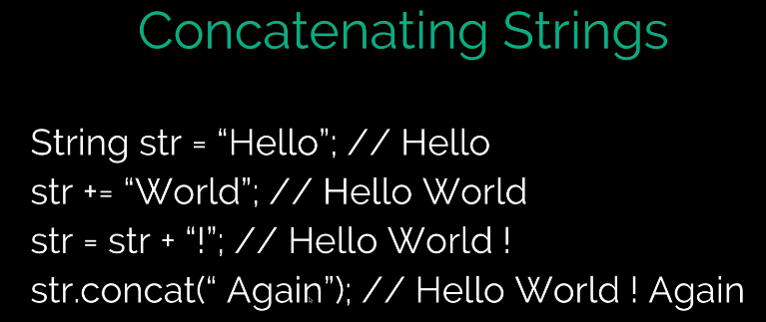

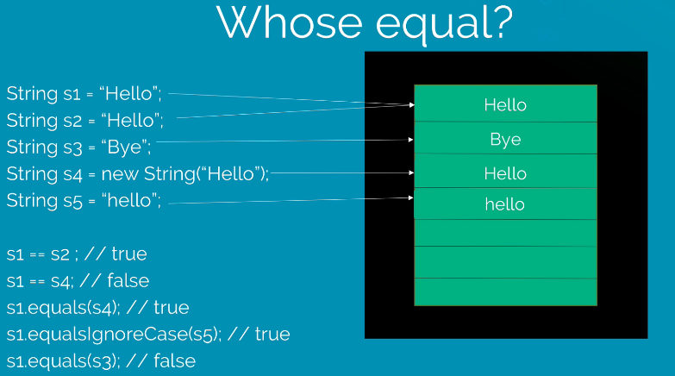

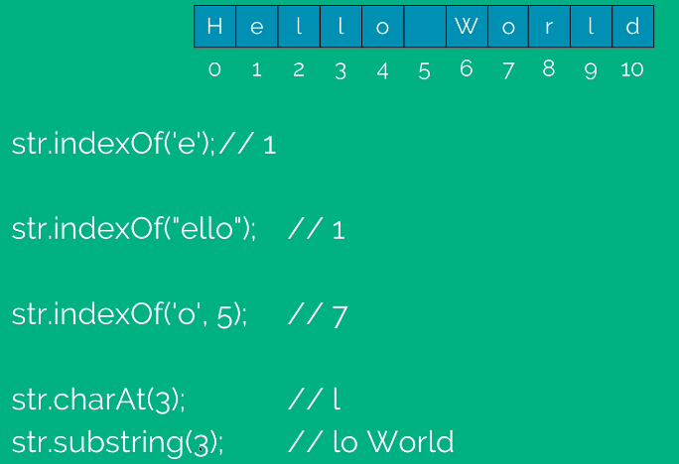

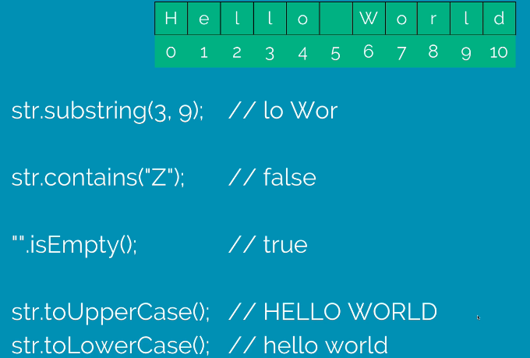

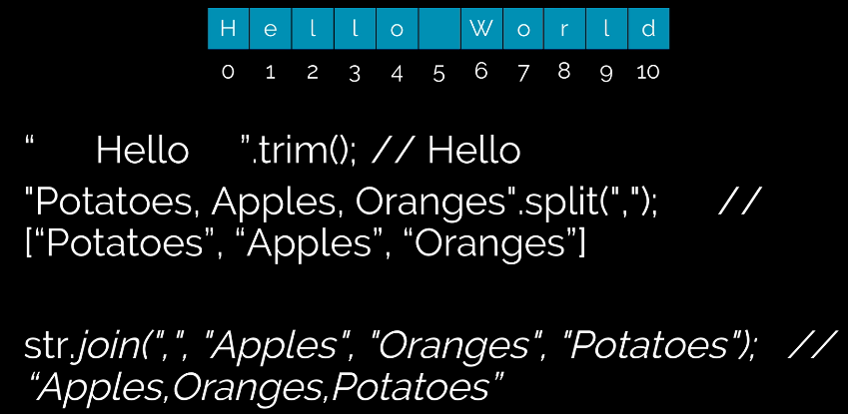

## String Builder And String conversions

# Methods

## Methods

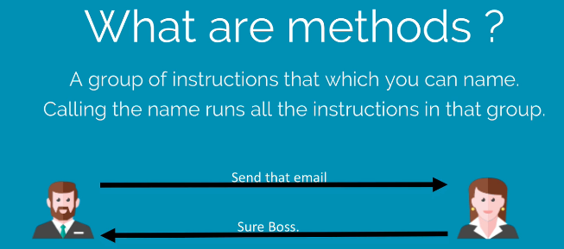

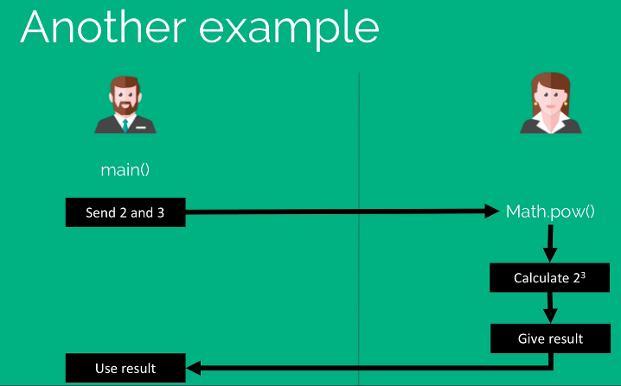

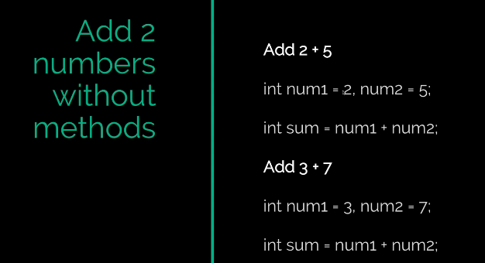

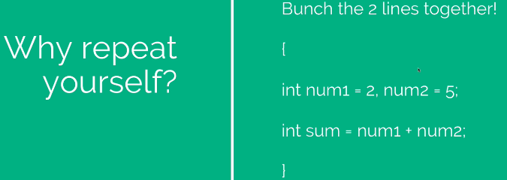

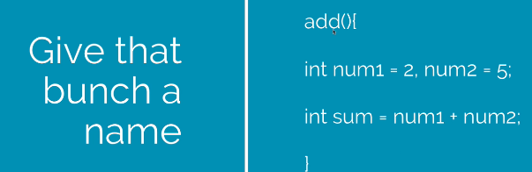

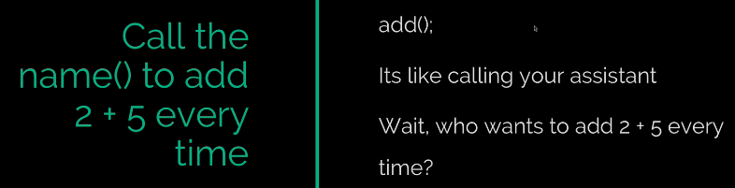

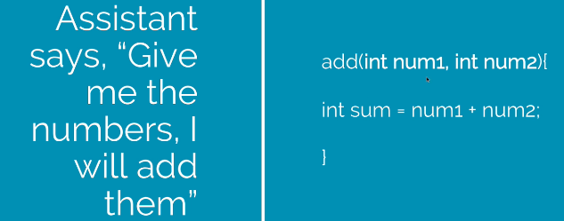

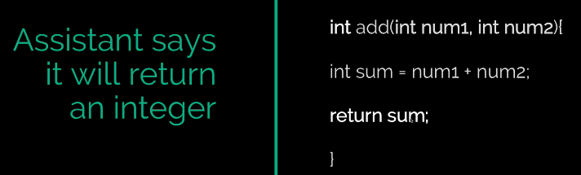

## Type Of Methods

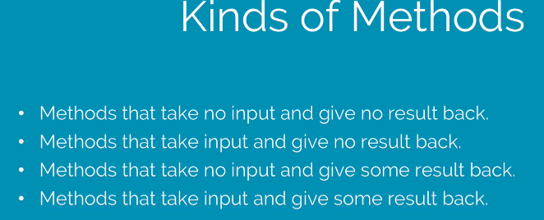



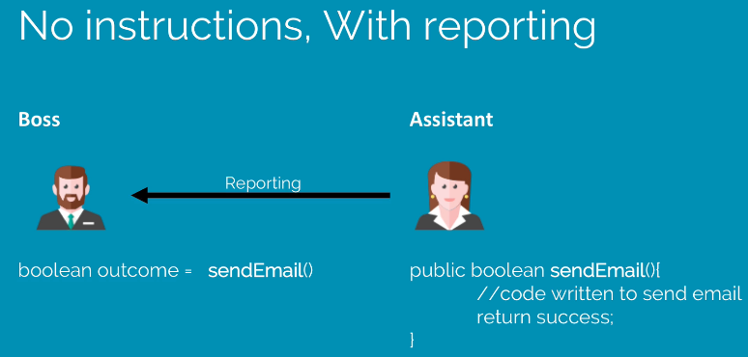

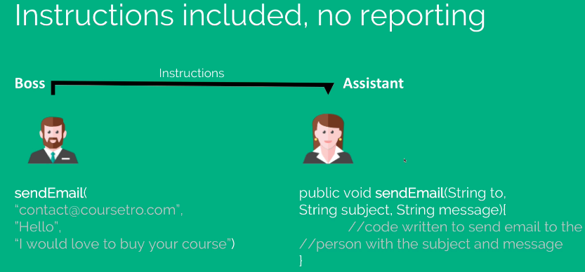

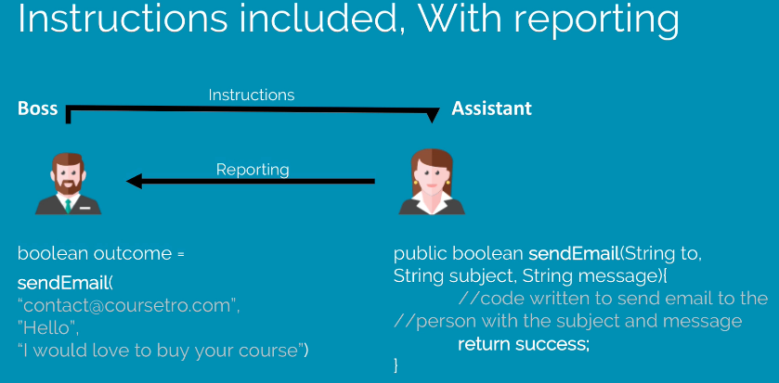

## Method Overloading

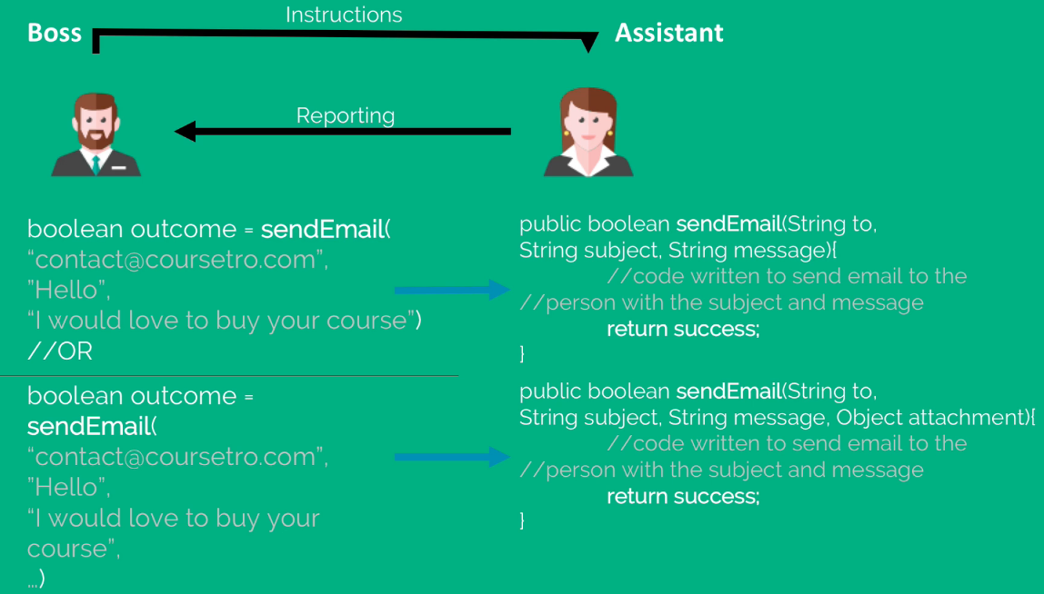

## Variable Scope

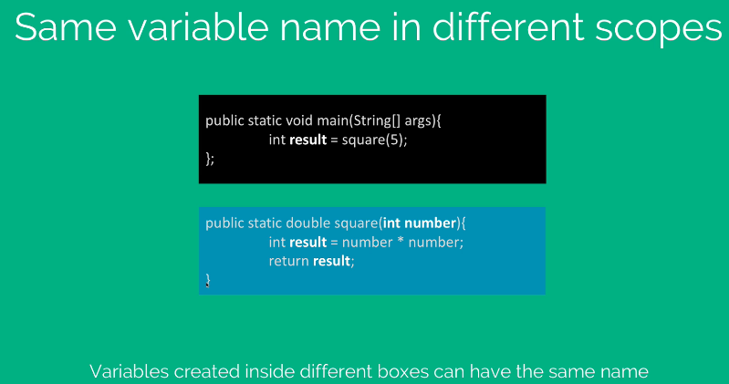

# Arrays

## One Dimensional Array

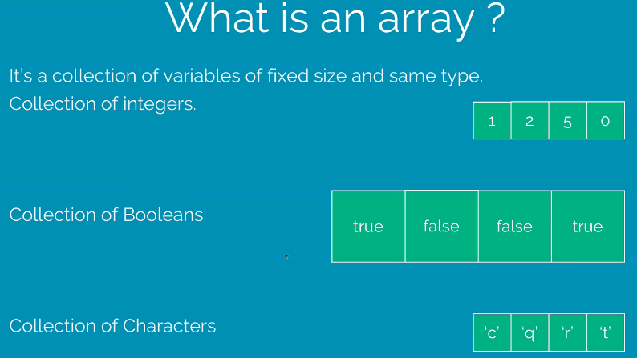

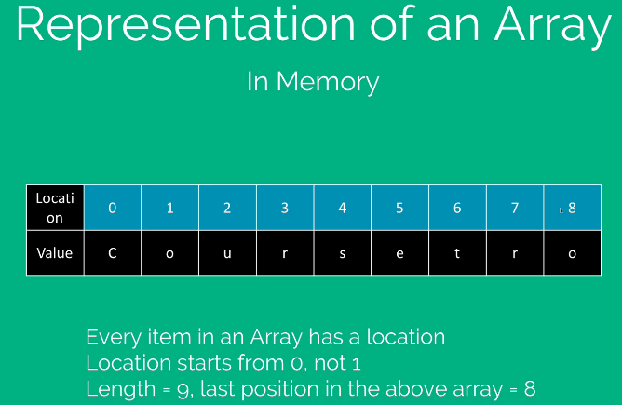



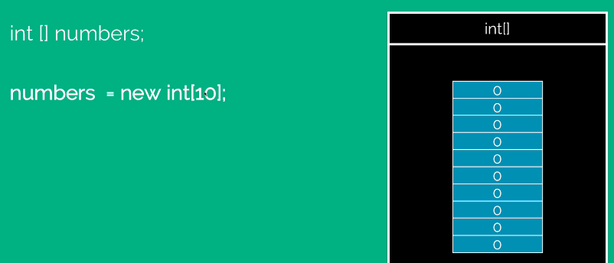

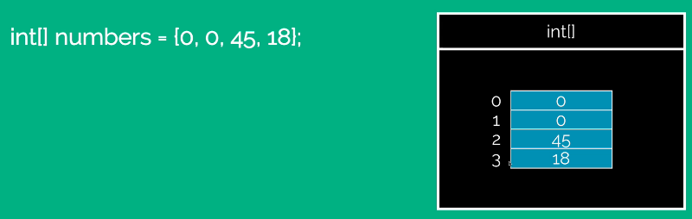

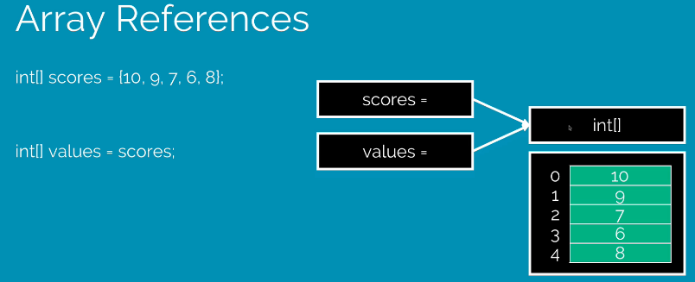

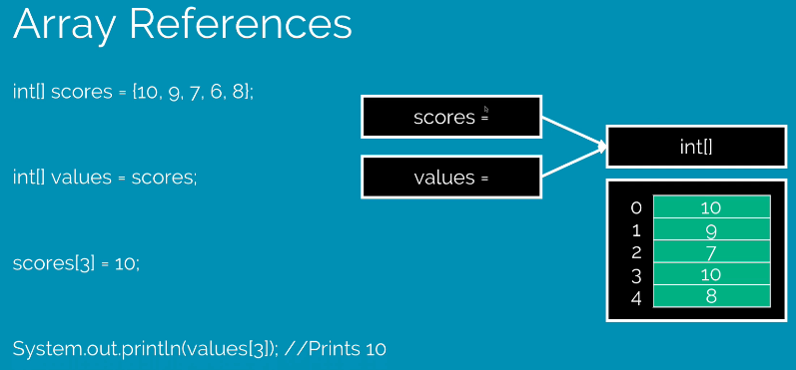

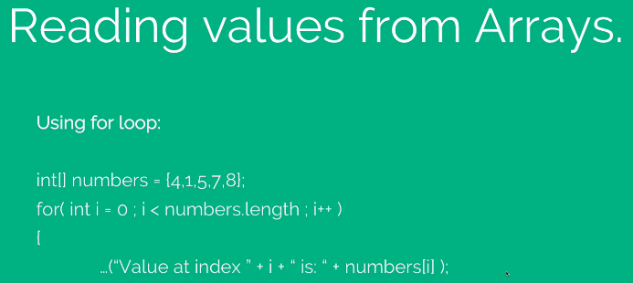

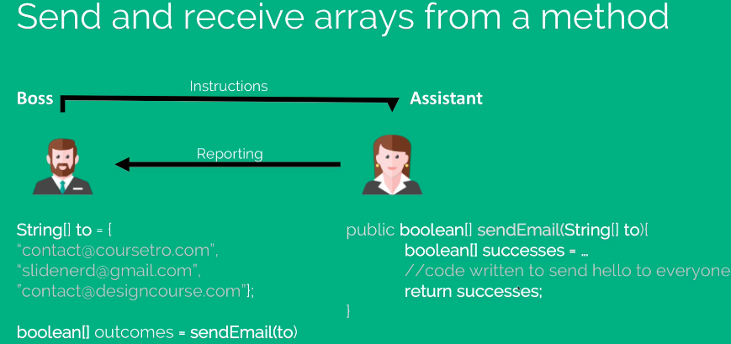

## Two Dimensional Array

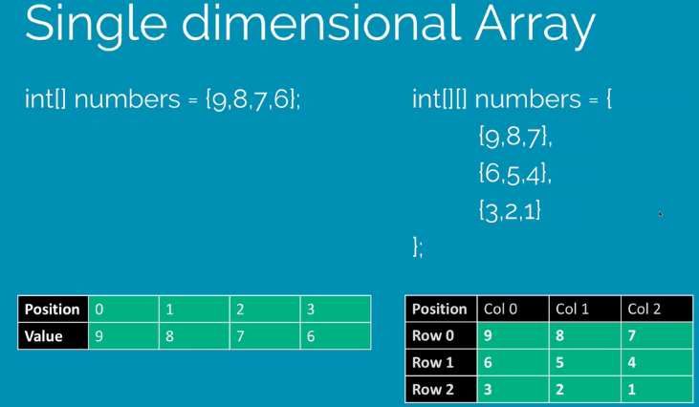

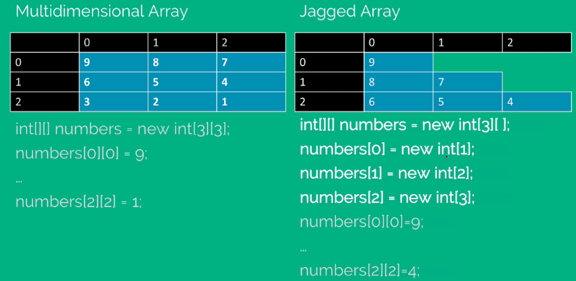

# Object Oriented Programming

## Classes and Objects

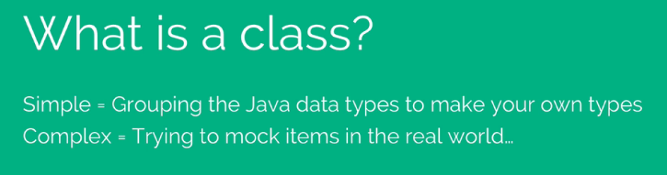

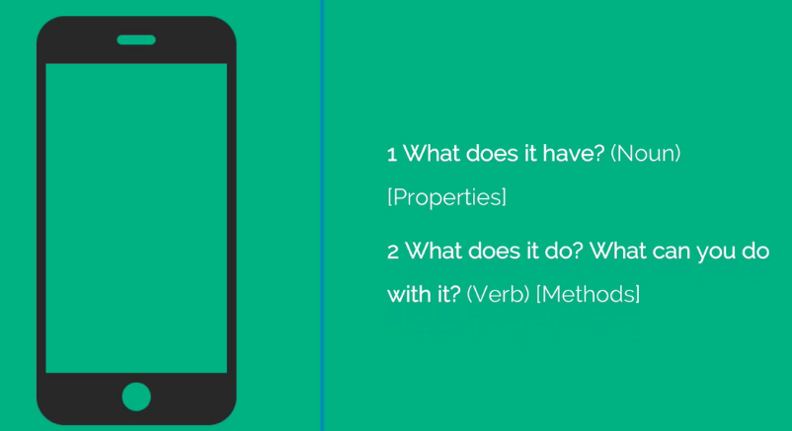

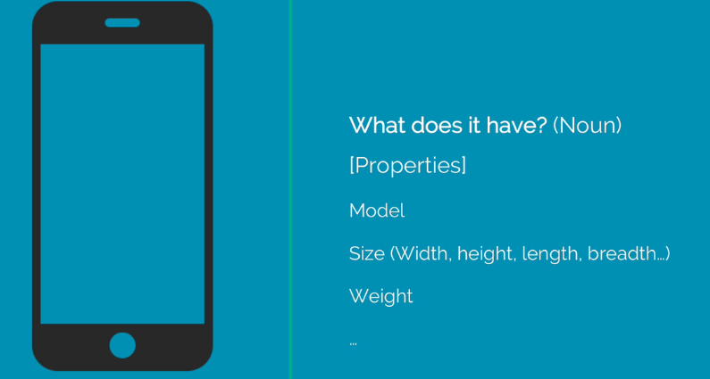

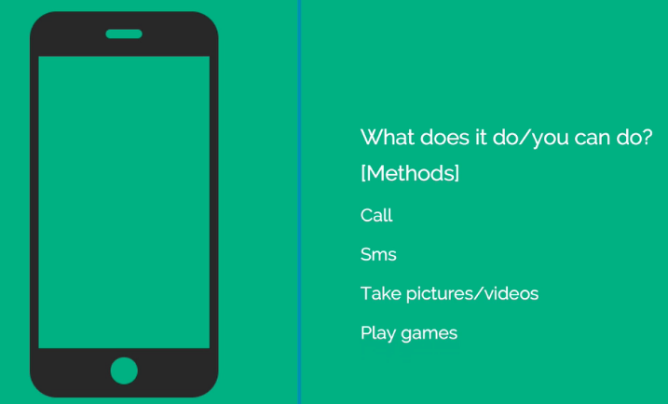



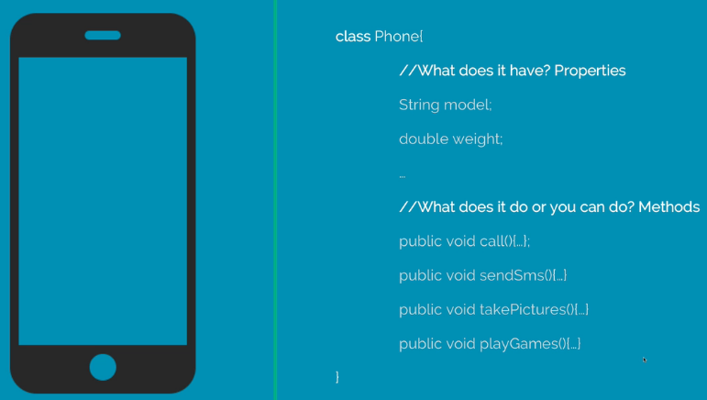

**public** **class** Phone {

String model;

**double** size;

**double** weight;

String maker;

**long** number;

**public** **void** setModel(String m) {

**this**.model = m;

}

**public** String getModel() {

**return** model;

}

**public** **double** getSize() {

**return** size;

}

**public** String getMaker() {

**return** maker;

}

**public** **long** getNumber() {

**return** number;

}

**public** **void** call() {

System.***out***.println("You phone makes cellular calls");

}

**public** **void** sendSms() {

System.***out***.println("Your phone can send SMS");

}

**public** **void** takePictures() {

System.***out***.println("Your phone can take good pictures");

}

}

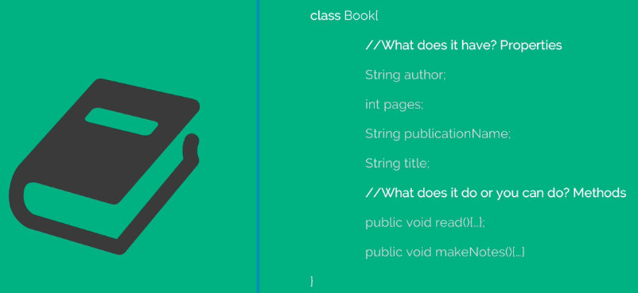

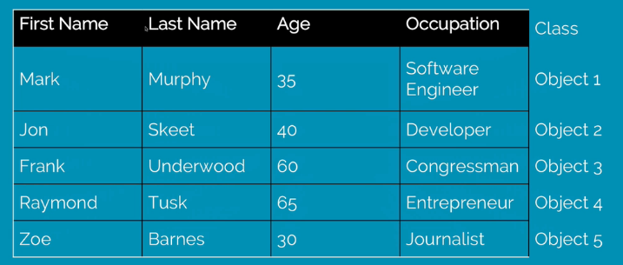

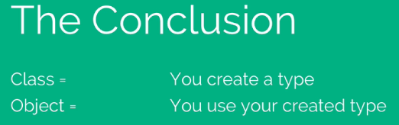

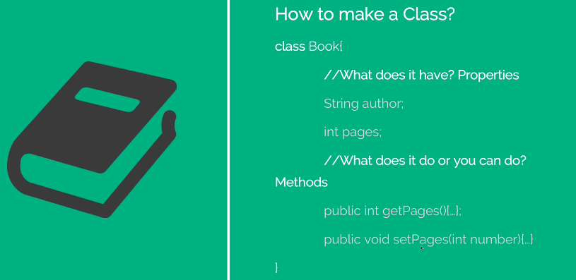

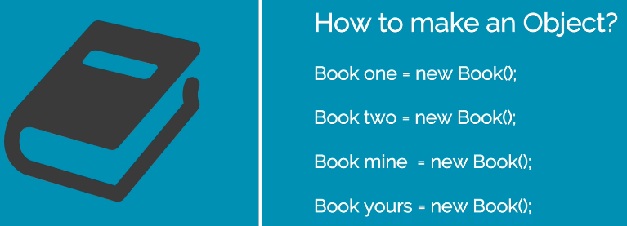

What happens when you make an object

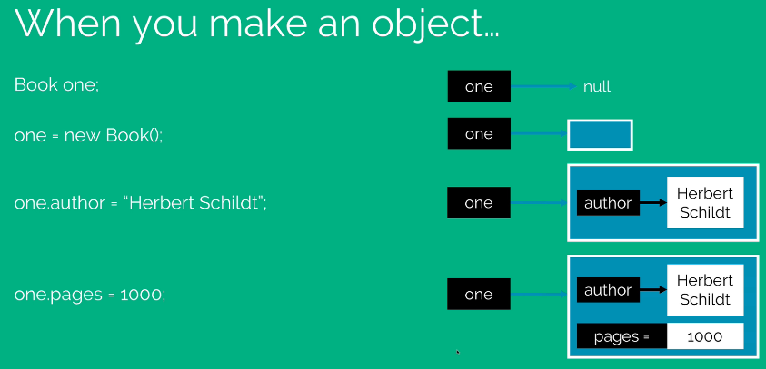

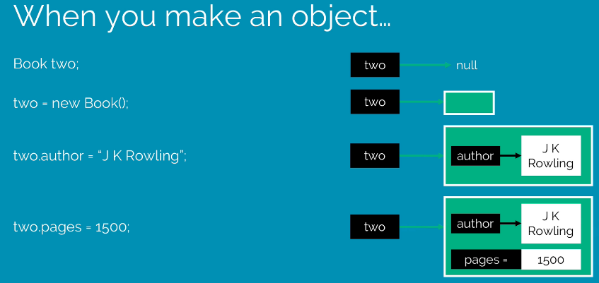

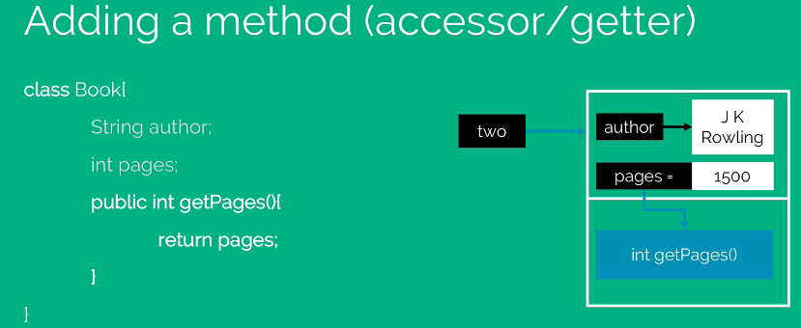

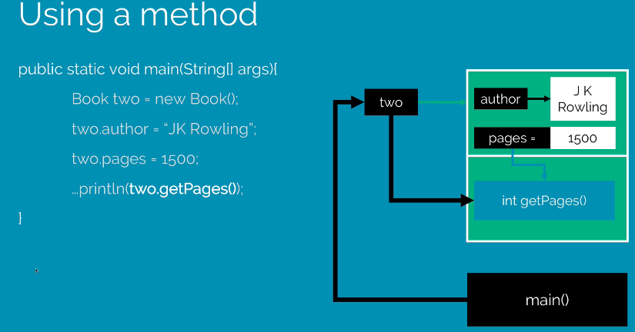

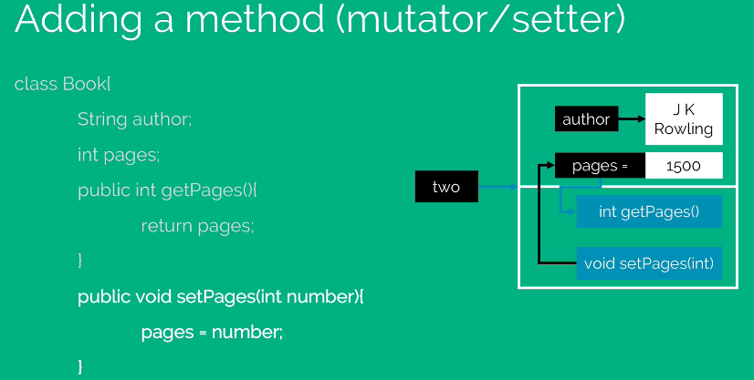

Examples:

**public** **class** ClassesAndObjectsTest {

**public** **static** **void** main(String[] args) {

Phone phone1 = **new** Phone(); // hashCode# 451

phone1.number = 2163333333L;

phone1.maker = "Apple";

phone1.size = 6.7;

//phone1.model = "iPhone7";

phone1.setModel("iPhone77777777");

System.***out***.println(phone1.getModel());

System.***out***.println(phone1.getMaker());

System.***out***.println(phone1.getNumber());

System.***out***.println(phone1.getSize());

// new Phone(); Create memory in Heap with empty data and with some addresss values called hashCode.

System.***out***.println("---------------------------------------");

Phone phone2 = **new** Phone(); // hashCode# 452

phone2.number = 2485294862L;

phone2.maker = "Samsung";

phone2.size = 7.5;

//phone2.model = "Galazy8";

phone2.setModel("Galaxy88888888");

System.***out***.println(phone2.getModel());

System.***out***.println(phone2.getMaker());

System.***out***.println(phone2.getNumber());

System.***out***.println(phone2.getSize());

Phone phone3 = **new** Phone(); // hashCode# 453

Phone phone4 = **new** Phone(); // hashCode# 454

Book book1 = **new** Book();

Phone phone5; // phone5 null

phone5 = **new** Phone();

}

}

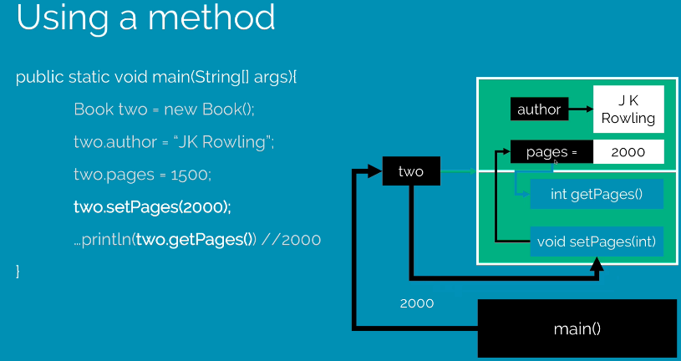

## Take Input from user

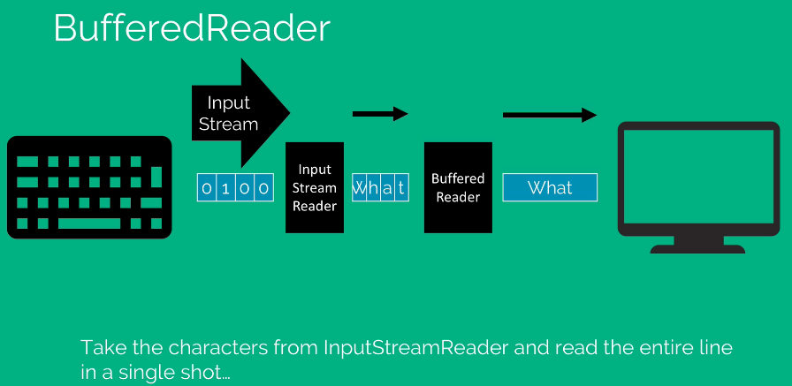

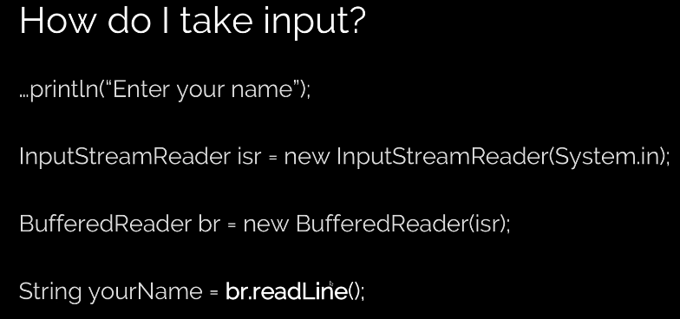

## ArrayList



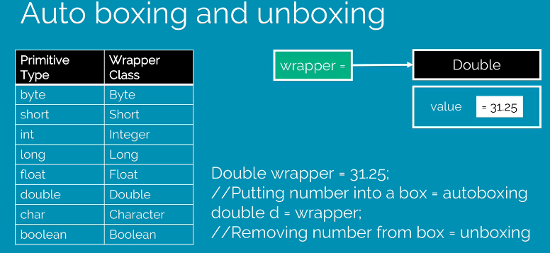

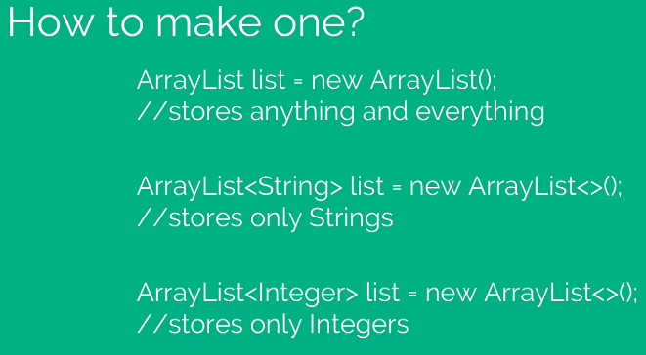

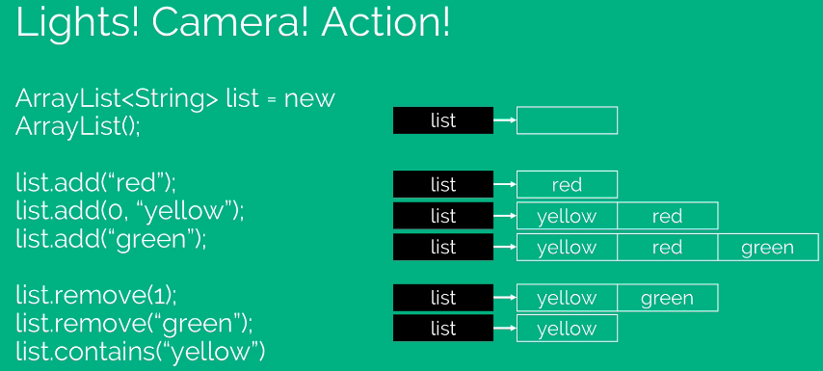

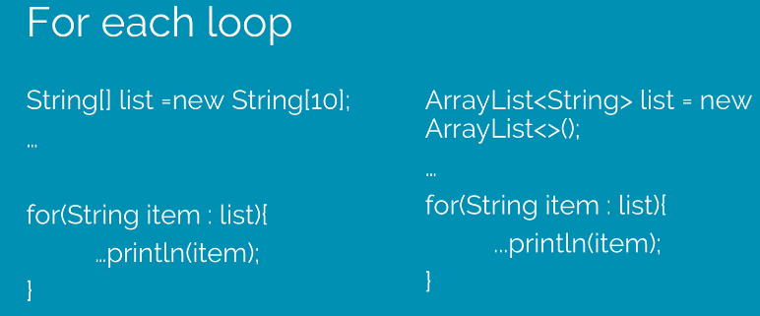

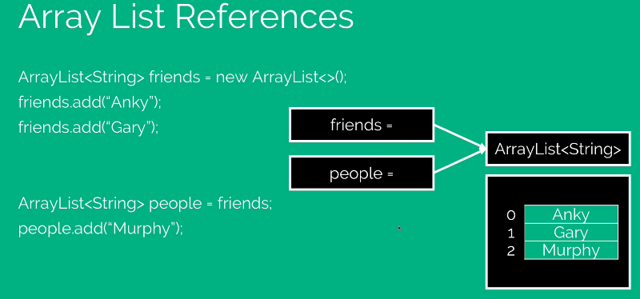

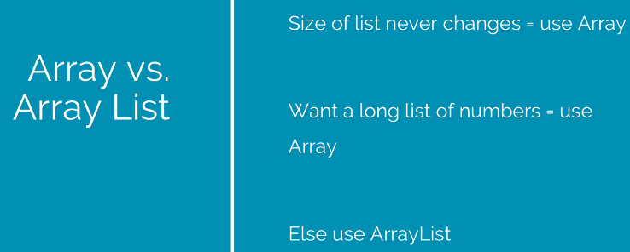

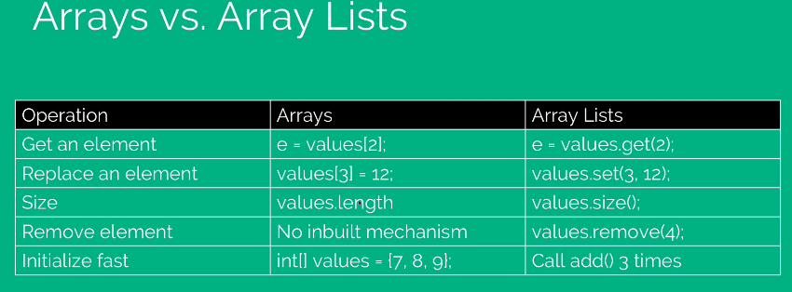

## Call By Value Vs Call by Reference

Will explain in later classes

## Constructor and Overlaoding

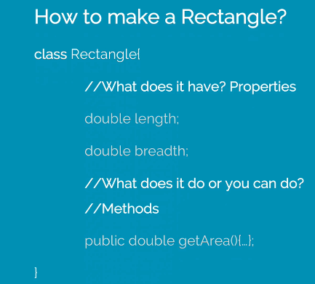

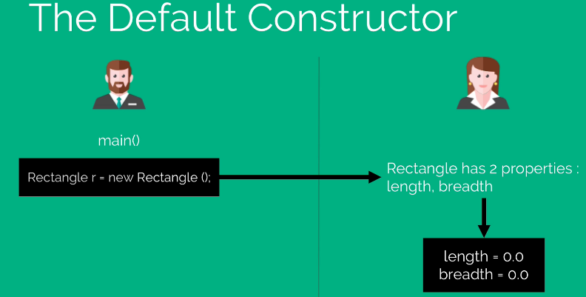

Phone phone2 = **new** Phone("Iphone7", 6.7, "Apple", 2.0, 3463456L, **true**);

//Customer constructor

**public** Phone(String model, **double** size, String maker, **double** weight, **long** number, **boolean** vr) {

System.***out***.println("In Phone custom Constructor");

**this**.model = model;

**this**.size = size;

**this**.maker = maker;

**this**.weight = weight;

**this**.number = number;

**this**.vr = vr;

}

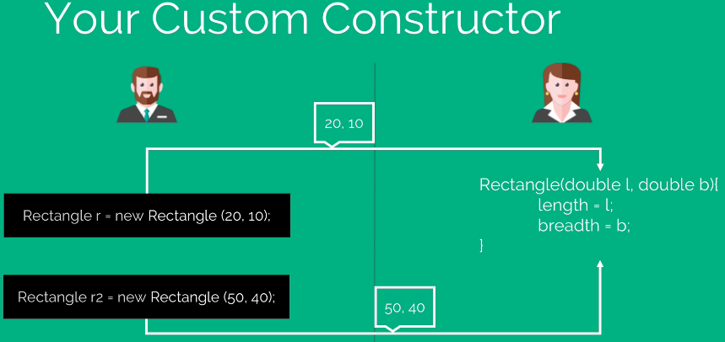

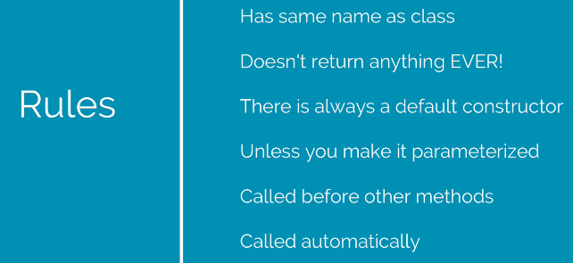

## Packages in java project

Simple example of java package

The package keyword is used to create a package in java.

//save as Simple.java

**package** mypack;

**public** **class** Simple {

**public** **static** **void** main(String args[]){

     System.out.println("Welcome to package");

    }

}

Q) How to access package from another package ?

A: There are three ways to access the package from outside the package.

import package.*;

import package.classname;

fully qualified name.

Advantage of Java Package

1) Java package is used to categorize the classes and interfaces so that they can be easily maintained.

2) Java package provides access protection.

3) Java package removes naming collision.

# Inheritance

## Static key word

## Inheritance

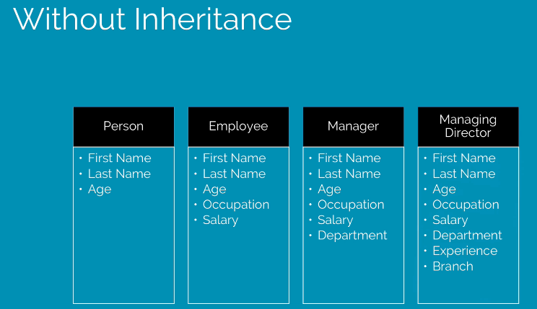

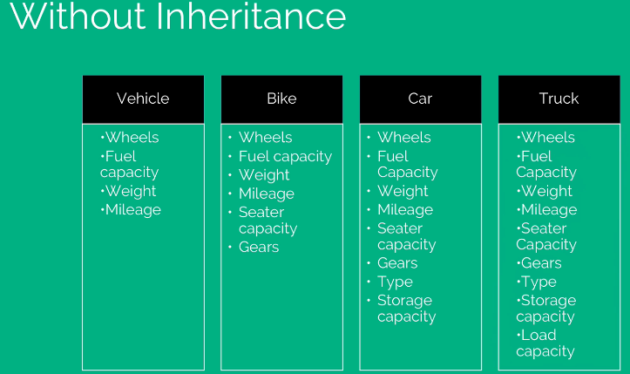



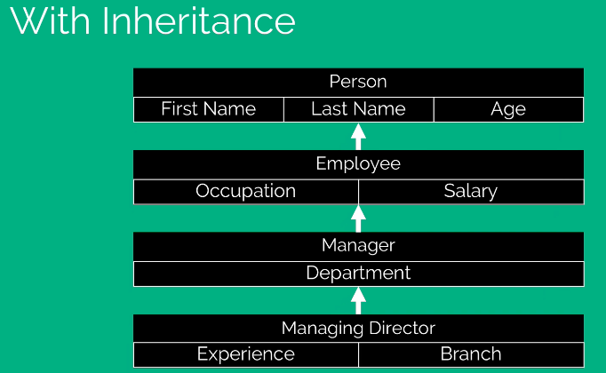

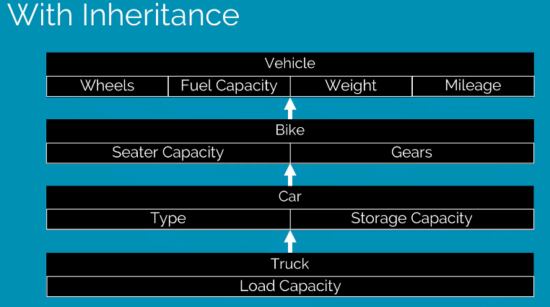

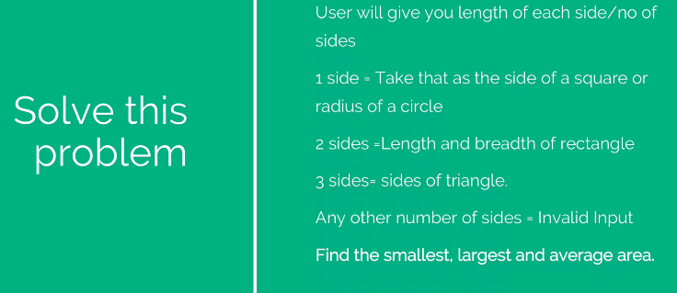

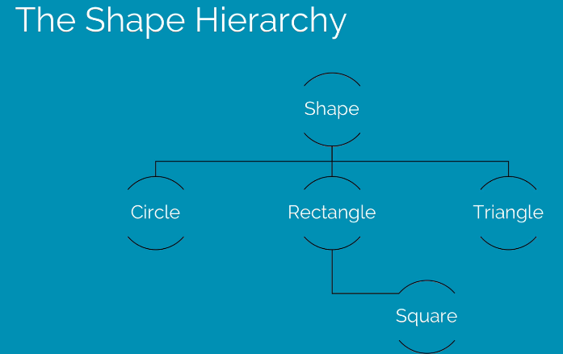

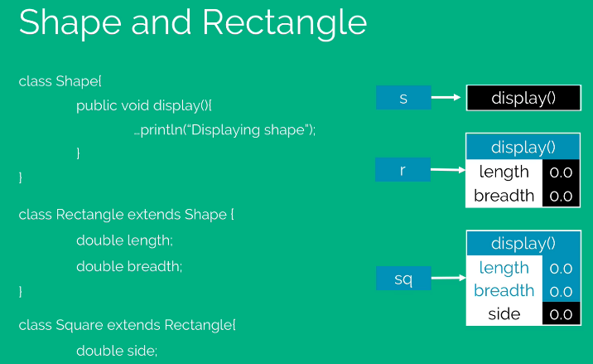

Shape s = new Shape();

Rectangle r = new Rectangle();

Square sq = new Square();

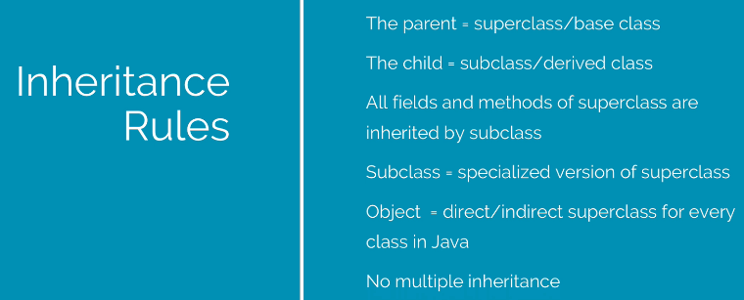

## Abstract class

A class that is declared with abstract keyword, is known as abstract class in java. It can have abstract and non-abstract methods (method with body).

Before learning java abstract class, let's understand the abstraction in java first.

**Abstraction** is a process of hiding the implementation details and showing only functionality to the user.

Another way, it shows only important things to the user and hides the internal details for example sending sms, you just type the text and send the message. You don't know the internal processing about the message delivery.

Abstraction lets you focus on what the object does instead of how it does it.

**Ways to achieve Abstaction:**

There are two ways to achieve abstraction in java

* Abstract class (0 to 100%)
* Interface (100%)

Syntax:

For Class:

**abstract** **class** Shape { }

Method:

**abstract** **void** calculateArea();//no body and abstract

## Interface

An **interface in java** is a blueprint of a class. It has static constants and abstract methods.

The interface in java is **a mechanism to achieve abstraction**. There can be only abstract methods in the java interface not method body. It is used to achieve abstraction and multiple inheritance in Java.

Java Interface also **represents IS-A relationship**.

It cannot be instantiated just like abstract class.

**Why use Java interface?**

There are mainly three reasons to use interface. They are given below.

* It is used to achieve abstraction.
* By interface, we can support the functionality of multiple inheritance.
* It can be used to achieve loose coupling.

Syntax:

**interface** Animal {

public abstract void sound();

 }

## abstract VS Interface

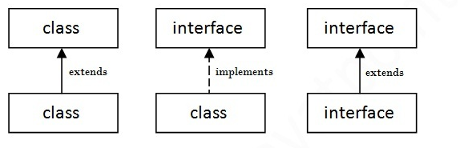

## this key work and variable hiding

## Super key word and method overriding



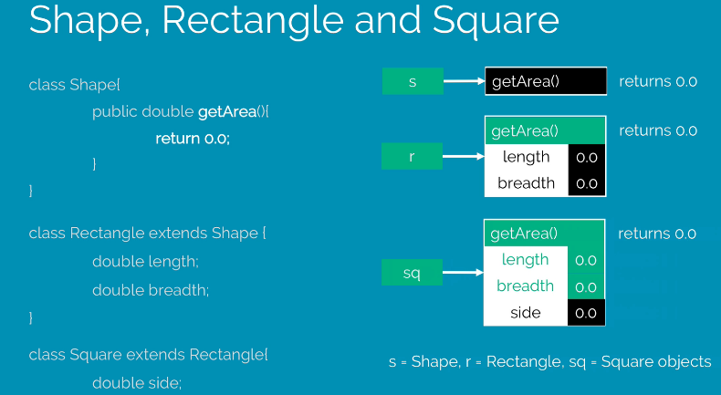

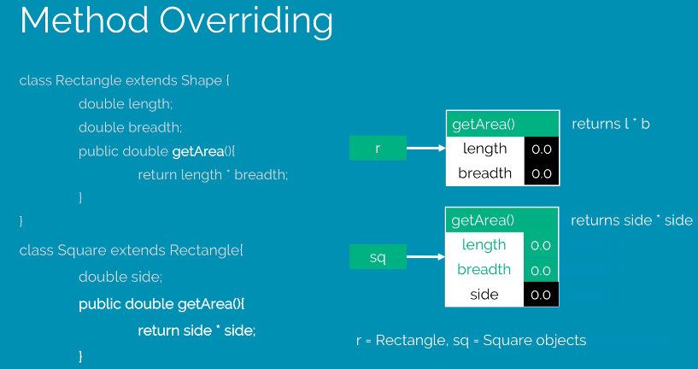

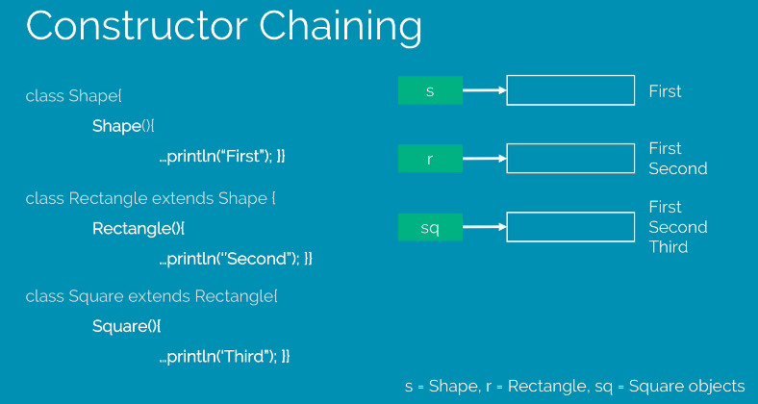

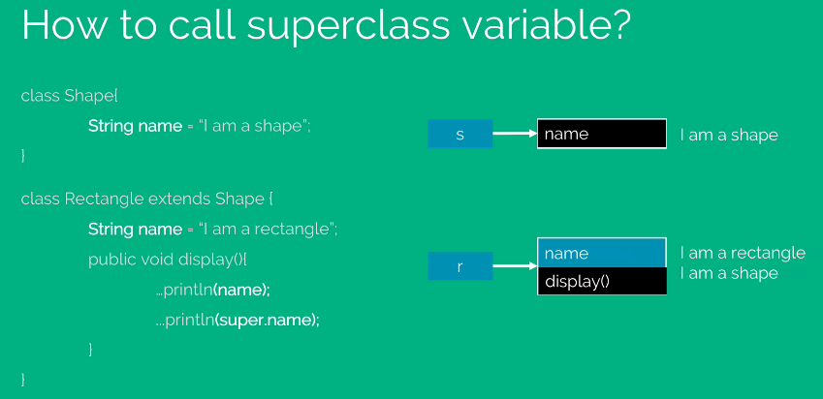

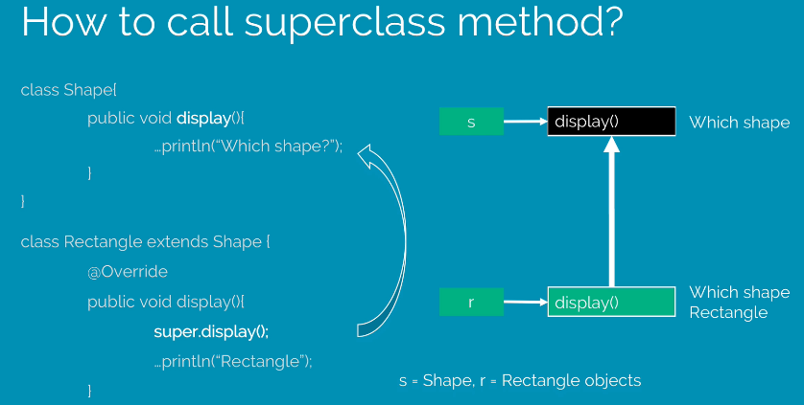

## Overloading vs overriding

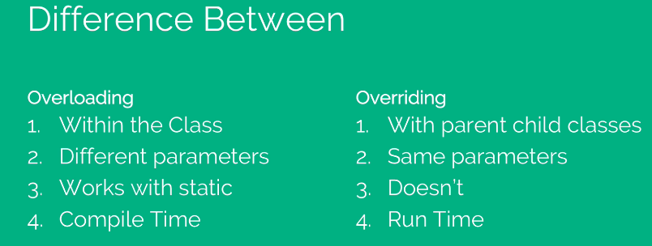

## Polymorphism with classes

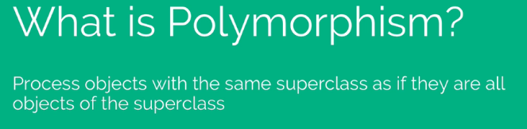

**public** **class** Rectangle **extends** Shape {

@Override

**public** **void** calculateArea() {

System.***out***.println("In Rectangle calcualteARea...");

**double** area = length * breath;

System.***out***.println("total Area of Rectangle is: " + area);

}

**public** **void** permiter() {

System.***out***.println("Perimeter is : " + (length + breath));

}

}

Shape rec = **new** Rectangle(3.0, 3.0);

rec.calculateArea();

rec.calculatePerimeter(); // Doesn’t work.

Now rec object doesn’t have access to any unimplemented methods in Rectangle class. rec object only has access to method that override in rectangle class from Shape class.

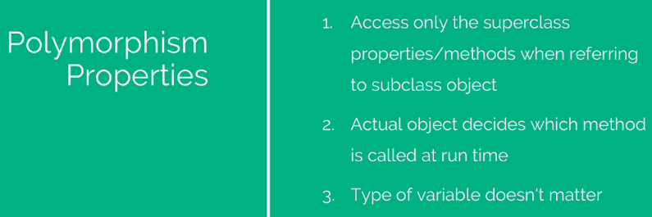

# Collections



## ArrayList and LinkedList

|  |  |
| --- | --- |
| **ArrayList** | **LinkedList** |
| 1) ArrayList internally uses **dynamic array** to store the elements. | LinkedList internally uses **doubly linked list** to store the elements. |
| 2) Manipulation with ArrayList is **slow** because it internally uses array. If any element is removed from the array, all the bits are shifted in memory. | Manipulation with LinkedList is **faster** than ArrayList because it uses doubly linked list so no bit shifting is required in memory. |
| 3) ArrayList class can **act as a list** only because it implements List only. | LinkedList class can **act as a list and queue** both because it implements List and Deque interfaces. |
| 4) ArrayList is **better for storing and accessing** data. | LinkedList is **better for manipulating** data. |

## HashMap and HashTable

|  |  |
| --- | --- |
| **HashMap** | **Hashtable** |
| 1) HashMap is **non synchronized**. It is not-thread safe and can't be shared between many threads without proper synchronization code. | Hashtable is **synchronized**. It is thread-safe and can be shared with many threads. |
| 2) HashMap **allows one null key and multiple null values**. | Hashtable **doesn't allow any null key or value**. |
| 3) HashMap is a **new class introduced in JDK 1.2**. | Hashtable is a **legacy class**. |
| 4) HashMap is **fast**. | Hashtable is **slow**. |
| 5) We can make the HashMap as synchronized by calling this code Map m = Collections.synchronizedMap(hashMap); | Hashtable is internally synchronized and can't be unsynchronized. |
| 6) HashMap is **traversed by Iterator**. | Hashtable is **traversed by Enumerator and Iterator**. |
| 7) Iterator in HashMap is **fail-fast**. | Enumerator in Hashtable is **not fail-fast**. |
| 8) HashMap inherits **AbstractMap** class. | Hashtable inherits **Dictionary** class. |

## TreeMap

The important points about Java TreeMap class are:

* A TreeMap contains values based on the key. It implements the NavigableMap interface and extends AbstractMap class.
* It contains only unique elements.
* It cannot have null key but can have multiple null values.
* It is same as HashMap instead maintains ascending order.

## HashSet

Difference between List and Set

List can contain duplicate elements whereas Set contains unique elements only.



The important points about Java HashSet class are:

* HashSet stores the elements by using a mechanism called **hashing.**
* HashSet contains unique elements only.

## TreeSet

The important points about Java TreeSet class are:

* Contains unique elements only like HashSet.
* Access and retrieval times are quiet fast.
* Maintains ascending order.

## Comparable and Comparator

**Comparable:**

We can sort the elements of:

1. String objects
2. Wrapper class objects
3. User-defined class objects

Collections class provides static methods for sorting the elements of collections. If collection elements are of Set or Map, we can use TreeSet or TreeMap. But We cannot sort the elements of List. Collections class provides methods for sorting the elements of List type elements.

**Syntax:**

**class** Customer **implements** Comparable<Customer>{

@Override

**public** **int** compareTo(Customer cust){

**if**(age==st.age)

**return** 0;

**else** **if**(age>st.age)

**return** 1;

**else**

**return** -1;

}

}

**Comparator:**

Java **Comparator** interface is used to order the objects of user-defined class.

1. AgeComparator.java
2. NameComparator.java
3. SalaryComparator.java

**public int compare(Object obj1,Object obj2):** compares the first object

with second object.

**Syntax:**

**class** AgeComparator **implements** Comparator{

@Override

**public** **int** compare(Object o1,Object o2){

Customer s1=(Customer)o1;

Customer s2=(Customer)o2;

**if**(s1.age==s2.age)

**return** 0;

**else** **if**(s1.age>s2.age)

**return** 1;

**else**

**return** -1;

}

}